1.
#include <math.h>
double sabc(double a, double b, double c) {
double p;
p = a / 2 + b / 2 + c / 2;
return sqrt(p * (p - a) * (p - b) * (p - c));
}
2.
#pragma warning(disable: 4996)
#include <stdio.h>
double p(int n) {
if (n == 0) return 1;
return n * p(n - 1);
}
int main() {
int m, n;
scanf("%d%d", &m, &n);
double A = p(m) / p(m - n);
printf("%lf", A);
return 0;
}

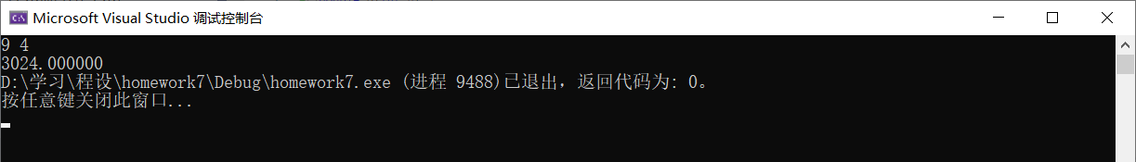

6.
int Fib(int n) {
if (n == 2 || n == 1) return 1;
return Fib(n - 1) + Fib(n - 2);
}

7.
int Ack(int n, int x, int y) {
if (!n) return (x + 1);
if (!y) {
if (n == 1 ) return x;
if (n == 2 ) return 0;
if (n == 3 ) return 1;
return 2;
}
return Ack(n - 1, Ack(n, x, y - 1), x);
}
10.
Two files:
//file1.c

int facsum(int n) {
int sum = 0 ;
for ( int i = 1; i < n; ++i) {
if (n % i == 0) sum += i;
}
return sum;
}

//file2.c

#pragma warning(disable:4996)
#include <stdio.h>
int facsum(int n);
int main() {
int sumOfWanshu = 0;
printf("500 yi nei suo you qin mi shu you:\n");
for (int i = 1; i < 500; ++i) {
int tmp = facsum(i);
if (tmp == i) {
sumOfWanshu += i;
printf("(%d,%d)\n", i, i);
}
else if (tmp < i) {
if (facsum(tmp) == i) {
printf("(%d,%d)\n", tmp, i);
}
}
}
printf("suo you wan shu zhi he wei:%d", sumOfWanshu);
return 0;
}

One file:
#pragma warning(disable:4996)
#include <stdio.h>
int facsum(int n) {
int sum = 0;
for (int i = 1; i < n; ++i) {
if (n % i == 0) sum += i;
}
return sum;
}
int main() {
int sumOfWanshu = 0;
printf("500 yi nei suo you qin mi shu you:\n");
for (int i = 1; i < 500; ++i) {
int tmp = facsum(i);
if (tmp == i) { //Wanshu
sumOfWanshu += i;
printf("(%d,%d)\n", i, i); //output the qinmishu
}
else if (tmp < i) { //Small number is in front of the big number.
if (facsum(tmp) == i) {
printf("(%d,%d)\n", tmp, i);
}
}
}
printf("suo you wan shu zhi he wei:%d", sumOfWanshu);
return 0;
}
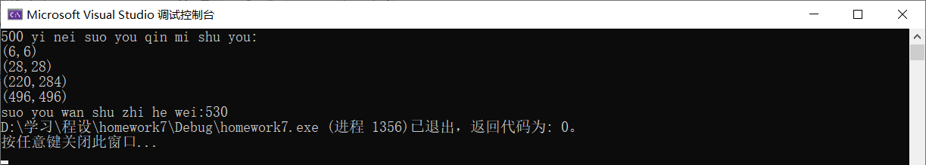
NS图：
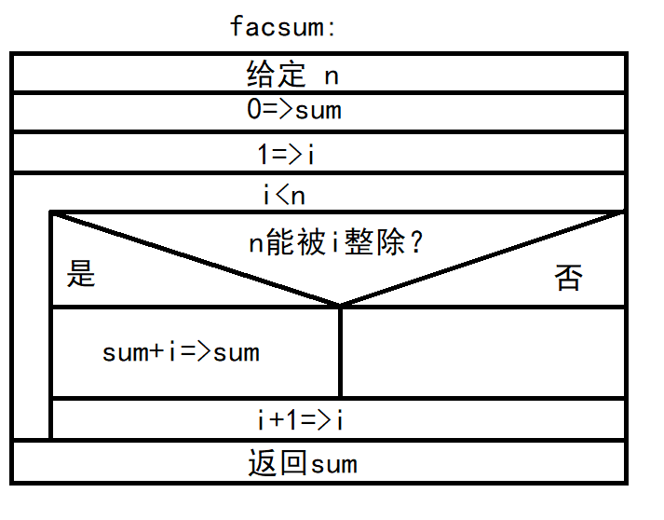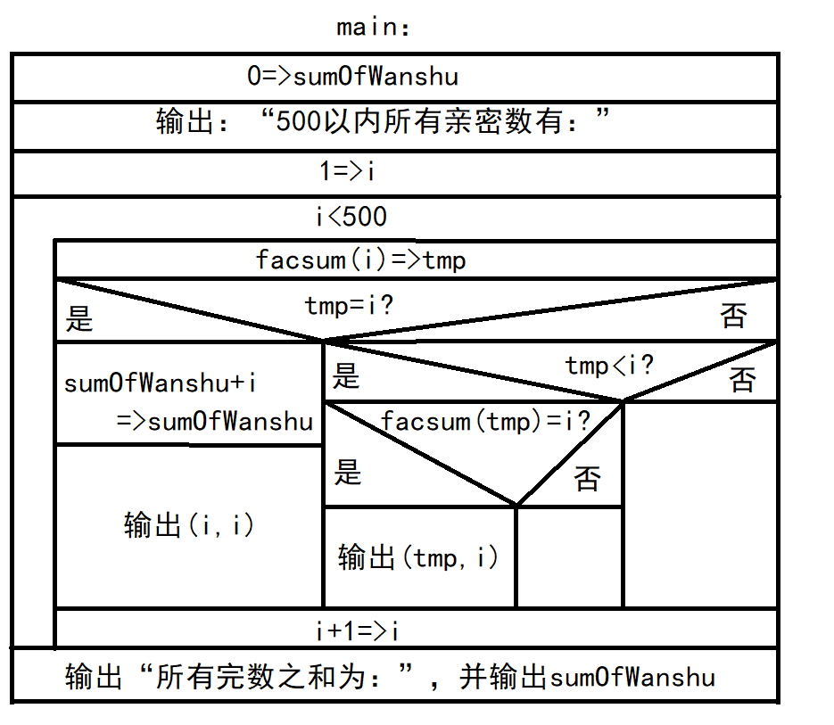
11.
#pragma warning(disable:4996)
#include <stdio.h>
unsigned long long fac(int k) {
if (k < 0) {
printf("ERROR!");
return 0;
}
if (k == 0) return 1;
return k * fac(k - 1);
}
int main() {
int m, n;
unsigned long long sum = 0;
printf("Please input m and n:\n");
scanf("%d%d", &m, &n);
if (m < 0 || n < 0 || m > n) printf("ILLEGAL!");
else {
sum = fac(m);
unsigned long long p = sum;
for (int i = m + 1; i <= n; ++i) {
p *= i;
sum += p;
}
printf("%llu", sum);
}
return 0;
}
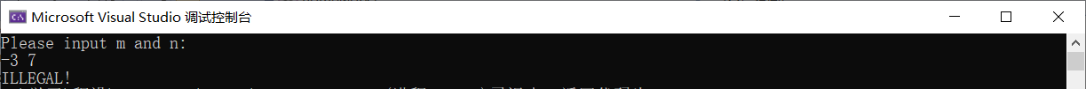
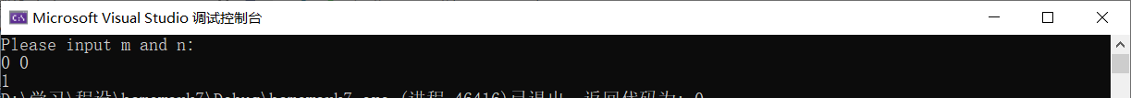
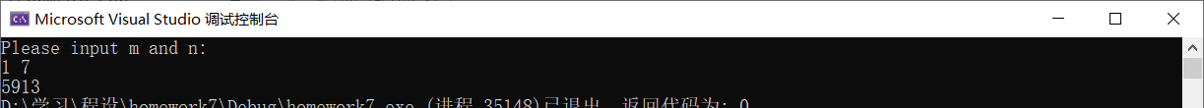
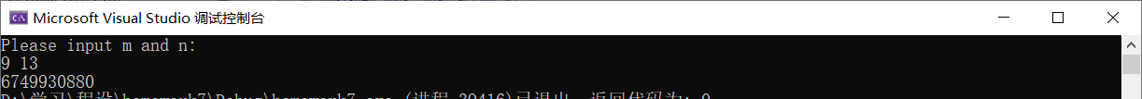
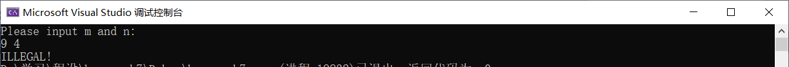
青蛙过河：
#pragma warning (disable:4996)
#include <stdio.h>
int frog(int y, int S) {
if (S == 0) return y + 1;
return 2 * frog(y, S - 1);
}
int main(){
int y, S;
scanf("%d%d", &y, &S);
printf("%d", frog(y, S));
return 0 ;
}
